USE CASE 1：Log in

|  |
| --- |
| USE CASE 1：Log in |
| **Related Requirem’ts:** REQ1, REQ7, REQ8  **Initiating Actor:** User  **Actor’s Goal:** Want to be able to record their own query results and history.  **Participating Actors:** User, Smart Phone  **Preconditions:** Software has the ability to create, store, and identify user credentials.  **Postconditions:** Provide login feedback.  **Flow of Events for Main Success Scenario:**  →User provides login request to software  ←Provide user login interface  ←User input credentials  ←verify login credentials  ←Successful verification (user login) / verification failed (re-enter credentials)  **Flow of Events for Extensions (Alternate Scenarios):**  →User provides login request to software  ←Provide user registration interface  →User created credentials  ←Save credentials and feedback to the user |

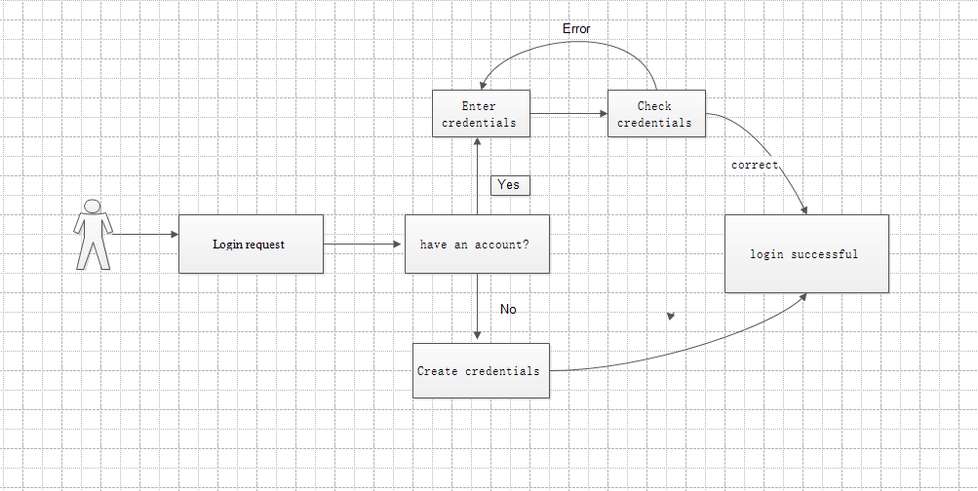

|  |
| --- |
| USE CASE 7：Add a departure reminder |
| **Related Requirem’ts:** REQ1, REQ6, REQ7  **Initiating Actor:** User  **Actor’s Goal:** Want to be reminded at a specific time before departure.  **Participating Actors:** User, Smart Phone  **Preconditions:** The user has made a travel plan and the phone has a reminder function.  **Postconditions:** Mobile phone vibration / ring alert  **Flow of Events for Main Success Scenario:**  →User input is reminded by mobile phone before (?) minutes/hour before travel.  ←Software saved and transmitted to the phone alarm clock software.  ←Alarm reminder |

